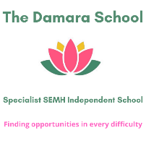

**Whole school curriculum coverage of Enrichment topics (2 year curriculum)**

|  |  |  |  |
| --- | --- | --- | --- |
| **Class** | **Autumn** | **Spring** | **Summer** |
| All groups year 1 | Monday: Sports Enrichment  My Body  Tuesday: Young Entrepreneur  Wednesday: Gardening/Horticulture  Thursday: Life Skills | Monday: Sports Enrichment  My Body  Tuesday: Young Entrepreneur  Wednesday: Gardening/Horticulture  Thursday: Life Skills | Monday: Sports Enrichment  My Body  Tuesday: Young Entrepreneur  Wednesday: Gardening/Horticulture  Thursday: Life Skills |
| All groups year 2 | Monday: Team Building  Tuesday: Gardening/Horticulture  Wednesday: Young Entrepreneur  Thursday: Life Skills | Monday: Coding - Co Space  Tuesday: Languages - Spanish  Wednesday: Young Entrepreneur  Thursday: Life Skills | Monday: Coding - Co Space  Tuesday: Languages - French  Wednesday: Young Entrepreneur  Thursday: Life Skills |